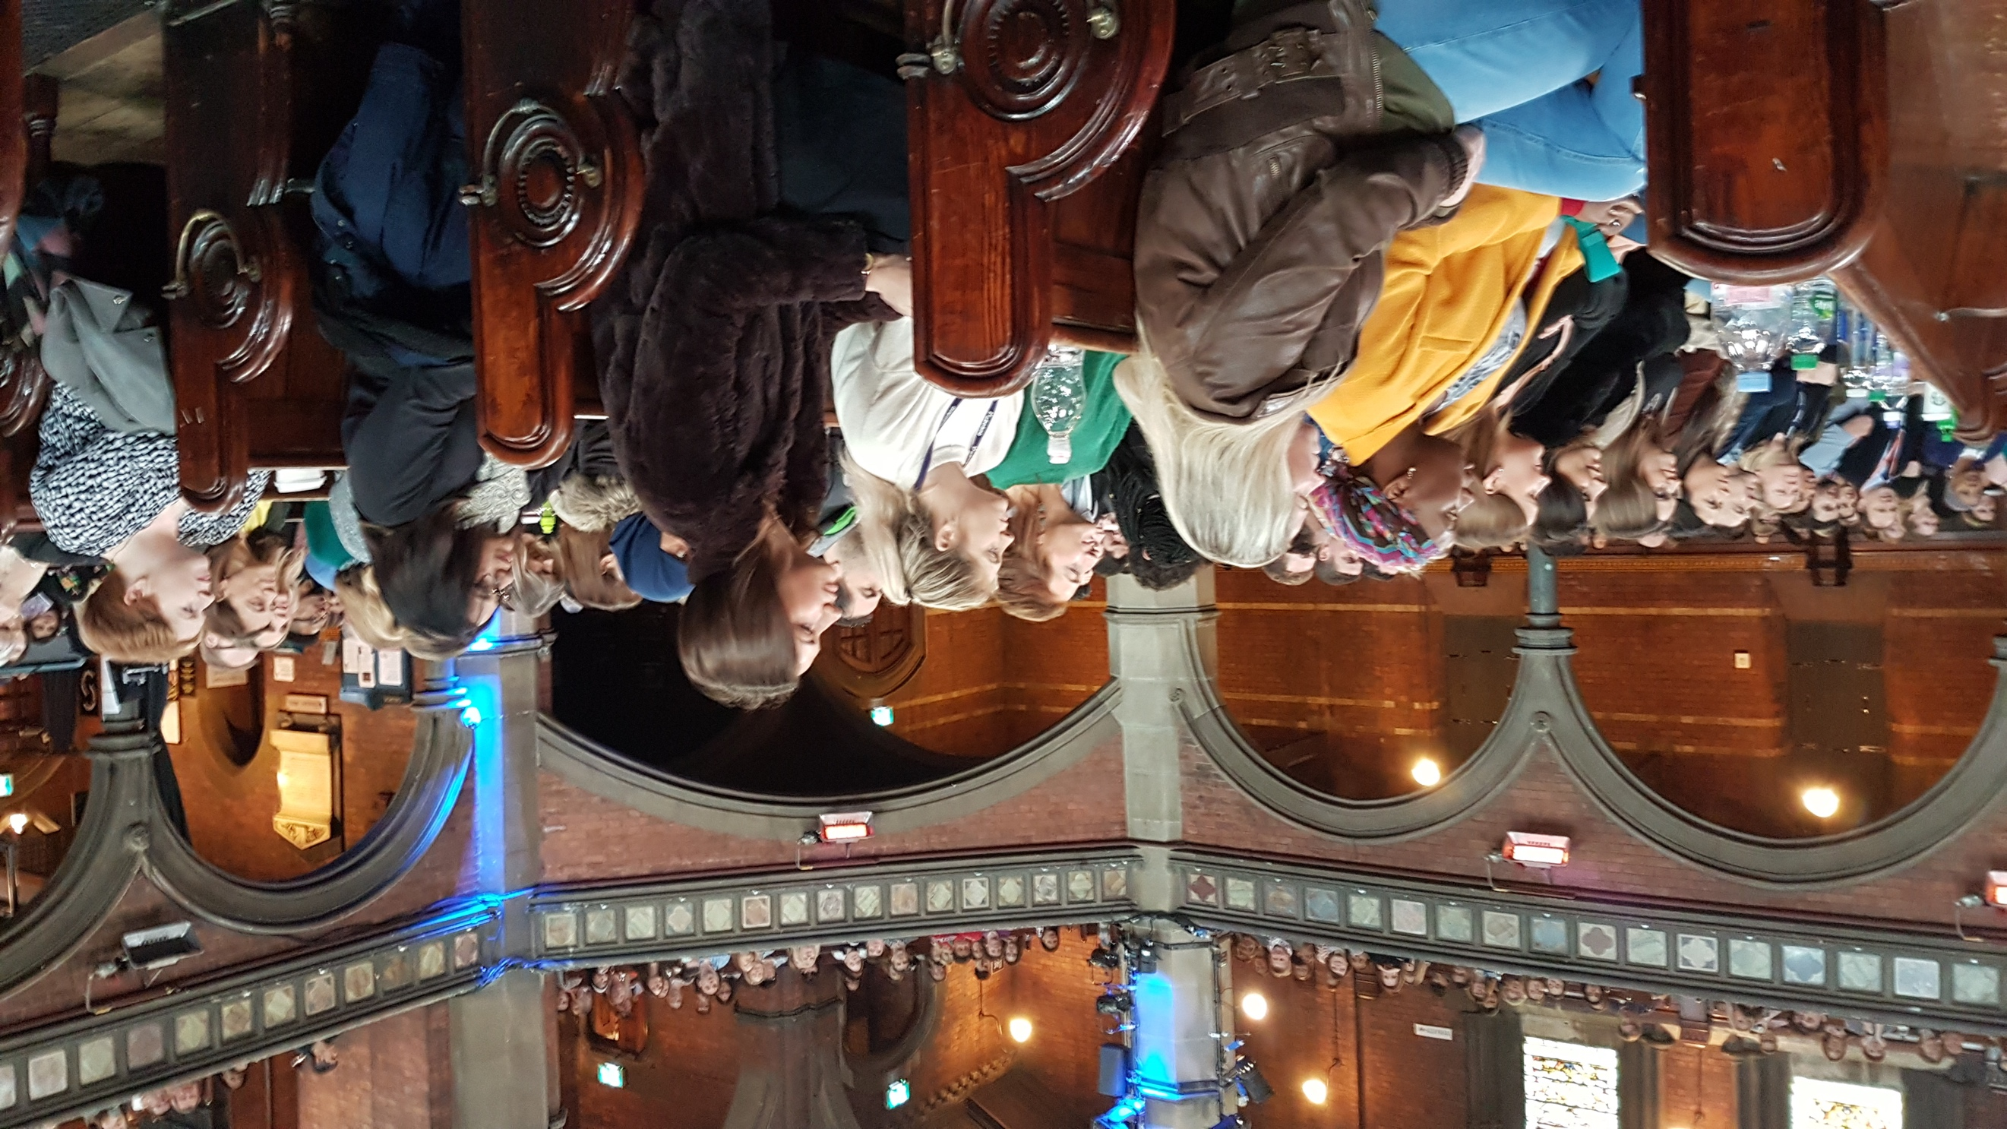

FutureZone Shared Inset 20th February 2017 with Matthew Syed

On the 20th February 2017 FutureZone hosted a shared Inset session for all 18 schools on Growth Mindset. The event was hosted at the beautiful Union Chapel in Islington and was attended by 750 staff from FZ school.

Matthew Syed was the guest speaker. Matthew is a British journalist, author and broadcaster. Prior to his journalistic career, Syed competed as an English table tennis international, and was the English number one for many years. He has published two books, Bounce in 2010, and Black Box Thinking in 2015.

Matthew challenged the myth of expertise and advocated growth mindsets in classrooms for pupils and teachers alike. Matthew’s speech built upon the FZ’s focus , this academic year, on” Dweck’s growth mindset and Ericsson’s deliberate practice. Following the speech, FZ schools spent the afternoon considering the implication for their setting and how they might move forward.

